**IsDate, Day, Month, Year and DateName DateTime functions in SQL Server - Part 26**

**ISDATE**() - Checks if the given value, is a valid date, time, or datetime. Returns 1 for success, 0 for failure.  
  
**Examples:**  
Select ISDATE('PRAGIM') -- returns 0  
Select ISDATE(Getdate()) -- returns 1  
Select ISDATE('2012-08-31 21:02:04.167') -- returns 1  
  
**Note**: For datetime2 values, IsDate returns ZERO.  
  
**Example**:  
Select ISDATE('2012-09-01 11:34:21.1918447') -- returns 0.  
  
  
  
  
  
  
**Day**() - Returns the **'Day number of the Month'** of the given date  
  
**Examples**:  
Select DAY(GETDATE()) -- Returns the day number of the month, based on current system datetime.  
Select DAY('01/31/2012') -- Returns 31  
  
**Month**() - Returns the **'Month number of the year'** of the given date  
  
**Examples**:  
Select Month(GETDATE()) -- Returns the **Month number of the year**, based on the current system date and time  
Select Month('01/31/2012') -- Returns 1  
  
**Year**() - Returns the**'Year number'**of the given date  
  
**Examples:**  
Select Year(GETDATE()) -- Returns the year number, based on the current system date  
Select Year('01/31/2012') -- Returns 2012  
  
**DateName**(DatePart, Date) - Returns a string, that represents a part of the given date. This functions takes 2 parameters. The first parameter **'DatePart'** specifies, the part of the date, we want. The second parameter, is the actual date, from which we want the part of the Date.  
  
**Valid Datepart parameter values**  
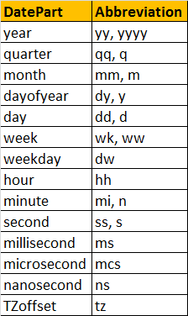  
  
  
**Examples:**  
Select DATENAME(Day, '2012-09-30 12:43:46.837') -- Returns 30  
Select DATENAME(WEEKDAY, '2012-09-30 12:43:46.837') -- Returns Sunday  
Select DATENAME(MONTH, '2012-09-30 12:43:46.837') -- Returns September  
  
A simple practical example using some of these DateTime functions. Consider the table tblEmployees.  
  
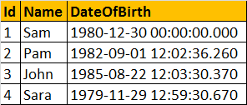  
  
Write a query, which returns Name, DateOfBirth, Day, MonthNumber, MonthName, and Year as shown below.  
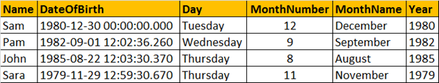  
  
  
**Query:**  
Select Name, DateOfBirth, DateName(WEEKDAY,DateOfBirth) as [Day],   
            Month(DateOfBirth) as MonthNumber,   
            DateName(MONTH, DateOfBirth) as [MonthName],  
            Year(DateOfBirth) as [Year]  
From   tblEmployees